Week 1 Report: Foundations of Design Engineering
Smart Temperature-Controlled Electronic Enclosure
Prepared by: Nimrah Saleem | Department of Electronic Engineering, NED University

1. Introduction
Design engineering is the process of converting a functional requirement into a practical product or system, considering performance, dimensions, materials, manufacturability, and safety. CAD (Computer-Aided Design) is used to create accurate 2D drawings and 3D models, design calculations justify dimensions and component choices, and engineering drawings communicate the information needed to manufacture the product.

2. Problem Statement
Electronic circuits generate heat during operation, and excessive temperature can reduce reliability or cause malfunction. A compact enclosure must provide physical protection while allowing heat to escape. The challenge is to design a small enclosure with organized component mounting, ventilation, cable access, and an automatic cooling mechanism.

3. Proposed System
The system uses a temperature sensor connected to an Arduino controller. The controller compares the measured temperature with predefined thresholds and controls a cooling fan and status indicators (LEDs and buzzer) accordingly.
System Flow: LM35 Temperature Sensor → Arduino UNO → Fan / LEDs / Buzzer
- Below 30°C — Fan OFF, Green LED (normal operation)
- 30–39°C — Fan ON, Yellow LED (active cooling)
- ≥40°C — Fan ON, Red LED + Buzzer (alert)

4. CAD Design of the Enclosure
The enclosure was modeled with outer dimensions of 150 mm (L) × 100 mm (W) × 60 mm (H) and a 3 mm wall thickness, including mounting standoffs, a fan opening, ventilation slots, and panel openings for LEDs, buzzer, and cables.
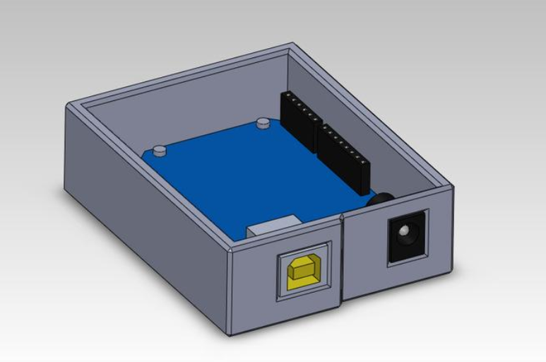
Figure 1: 3D CAD Model of the Enclosure (Closed)
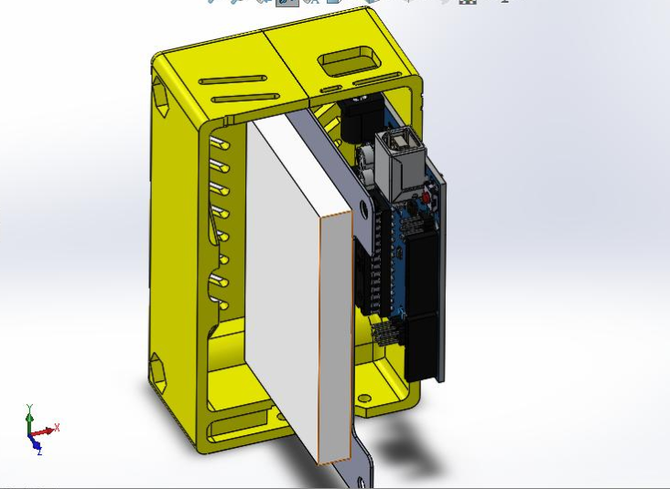
Figure 2: Internal Assembly View — PCB and Component Placement

5. Design Calculations
- Enclosure volume: V = 150 × 100 × 60 = 900,000 mm³ = 0.9 L
- Fan power: P = 5V × 0.20A = 1.0 W
- Controller/sensor power: P = 5V × 0.10A = 0.50 W
- Total estimated load with 25% margin: 1.5 W × 1.25 = 1.875 W
- Wall thickness: 3 mm (prototype value); Mounting: M3 fasteners

6. Engineering Drawings
The drawing package includes front, top, side, and rear views with dimensions in millimeters, plus an isometric and exploded view for assembly clarity.
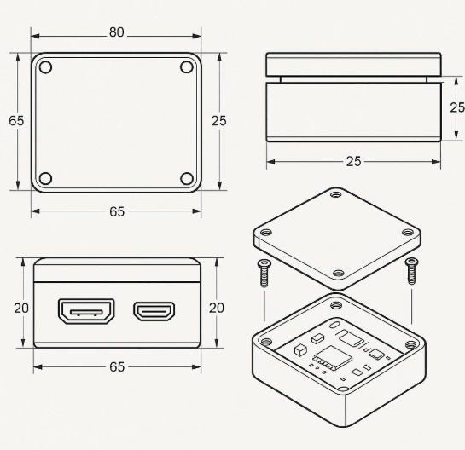
Figure 3: Engineering Drawing — Orthographic Views (mm) and Exploded Assembly

7. Conclusion
Week 1 covered the fundamentals of the design engineering workflow — CAD modeling, design calculations, and engineering drawings — applied here to a temperature-controlled electronic enclosure. The CAD environment was set up and used to produce a dimensioned 3D model and drawing package, forming the foundation for prototype development in the following weeks.

